Implementation Plan: Governor Nelson State Park Recreation Web App

*diagram at the bottom

**Phase 1: Data Collection & Preparation (Week 1)**

* Visit Governor Nelson State Park to collect primary data using ArcGIS Field Maps (I have used this before for my own data collection, and it's very useful and integrated!)
* Capture coordinates and descriptive attributes for:
  + Trails
  + Restrooms
  + Picnic areas
  + Parking lots
  + Initial scenic points
* Organize data in shapefile or GeoJSON format.
* Set up PostgreSQL/PostGIS database with spatial extensions enabled.
* Prepare base schema for each layer using SQL.
* Begin prelim testing of data imports into PostGIS.

**Phase 2: Frontend Development (Week 2)**

* Build responsive HTML/CSS layout using Bootstrap. Am going the web app route for accessibility. It would not make sense to develop an app for people to install from an App Store for a single park.
* Initialize ArcGIS JavaScript API map and load all static data layers.
* Add popups for park features (restrooms, picnic areas, scenic, etc.).
* Build UI for user-submitted scenic locations:
  + Submission form with validation. Using Survey123, I have done something similar to this before with a 576 project.
  + Point placement on map
* Add controls for device location, layer toggles, and basic search tools.

**Phase 3: Backend Development & User Submission Integration (Week 3)**

* Build Flask server to handle:
  + Scenic point submissions (insert into PostGIS with validation)
  + Queries for spatial filtering (e.g., trail by distance, elevation possibly?)
  + Optional: elevation analysis (if data available via API or DEM). Will do some digging for this data.
* Connect frontend submission form to backend via AJAX or Fetch API.
* Secure routes and sanitize inputs to protect DB integrity.
* Begin integration testing across devices (mobile/desktop). (over the weekend)

**Phase 4: Demo, Testing & Final Edits (Week 4)**

* Conduct full walkthrough of user stories to ensure all functions work:
  + Find scenic areas
  + Identify potential running routes with elevation/length info
  + Use search, location, and popups
  + Submit scenic points successfully
* Make UI tweaks based on usability testing.
* Record 5-minute demo video.
* Finalize written report, ER diagram, and logical schema.

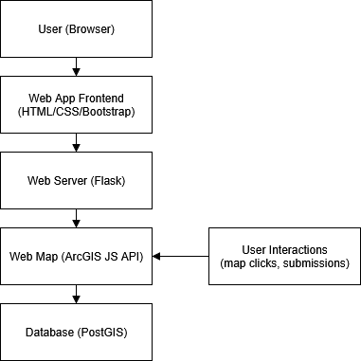Pretty simple linear design, not sure that it needs to be any more complex than this?